## **FUNCTIONAL INTERFACES**

-------------------------------------------------------------------------------------------------------------------------------

**Notes:**

-> A functional Interface is an interface that contains only one abstract method.

-> Examples: Runnable

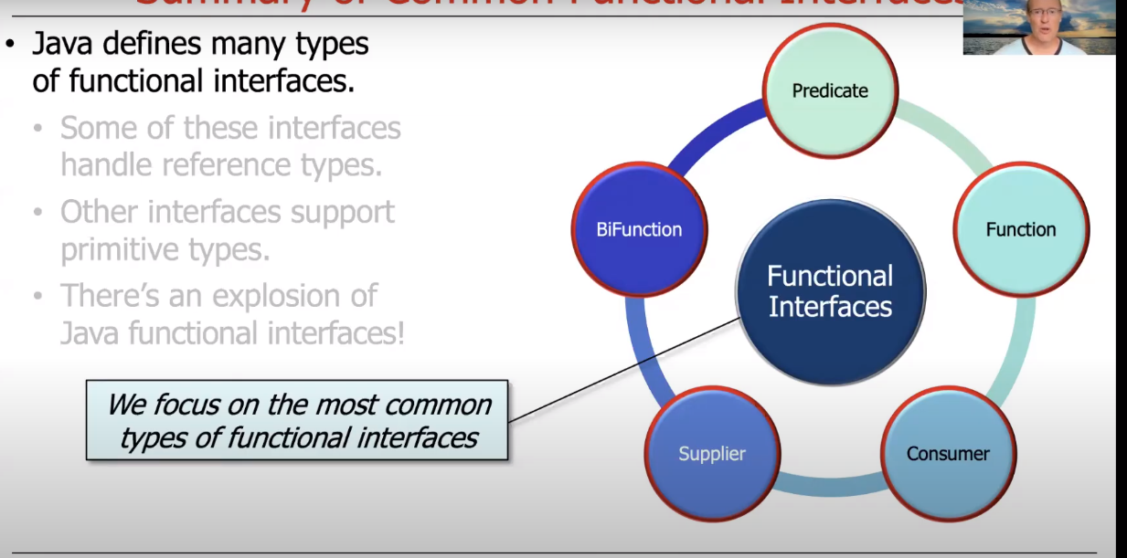

## **PREDICATE FUNCTION**

-------------------------------------------------------------------------------------------------------------------------------

**Notes:**

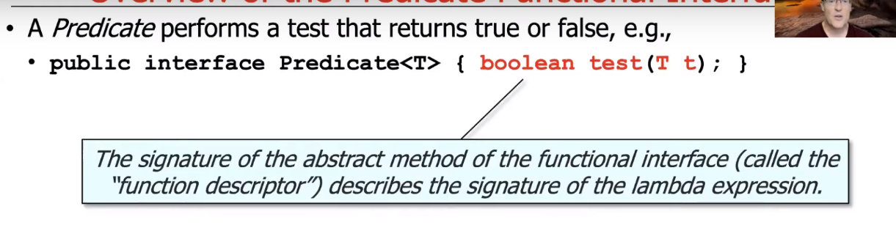

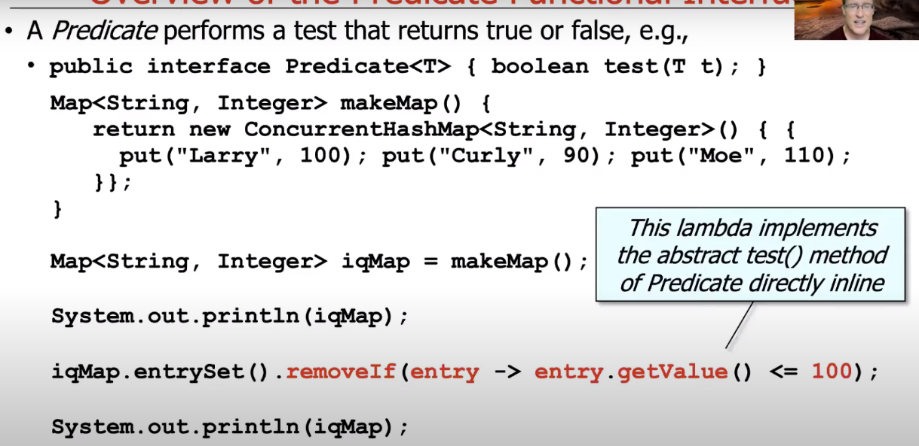

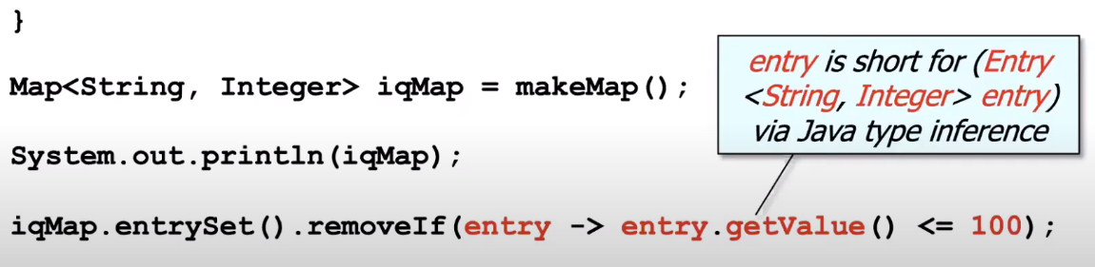

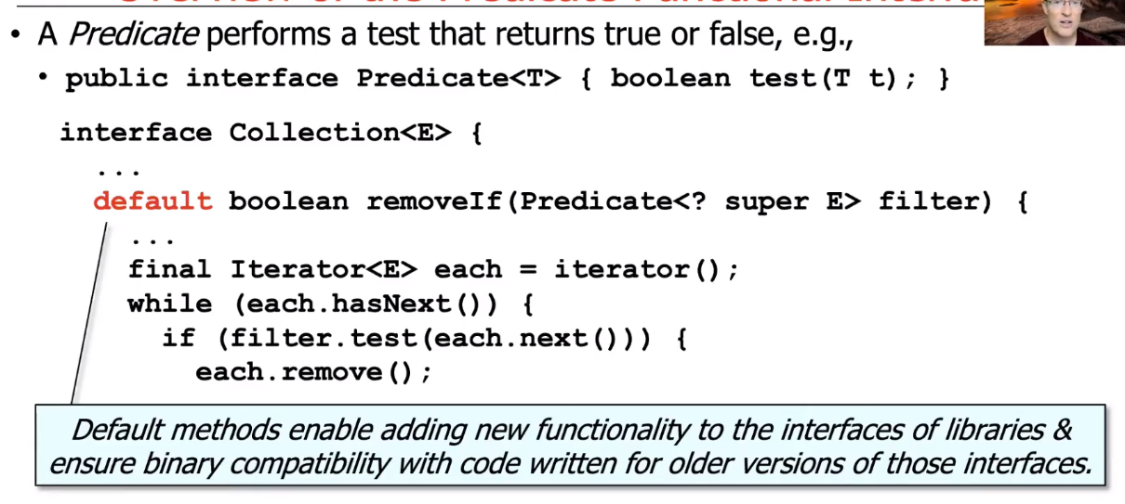

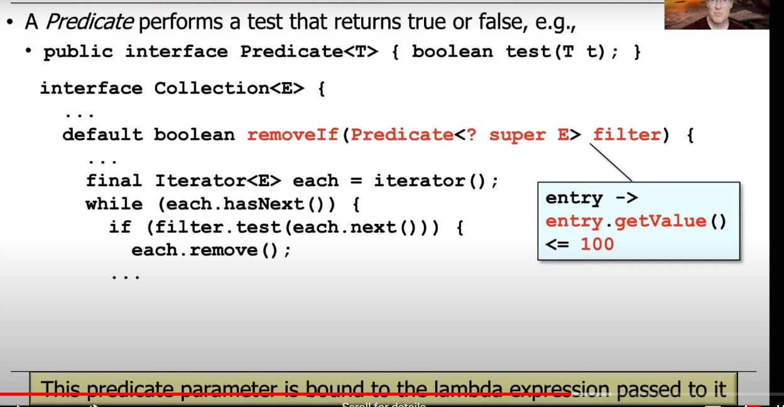

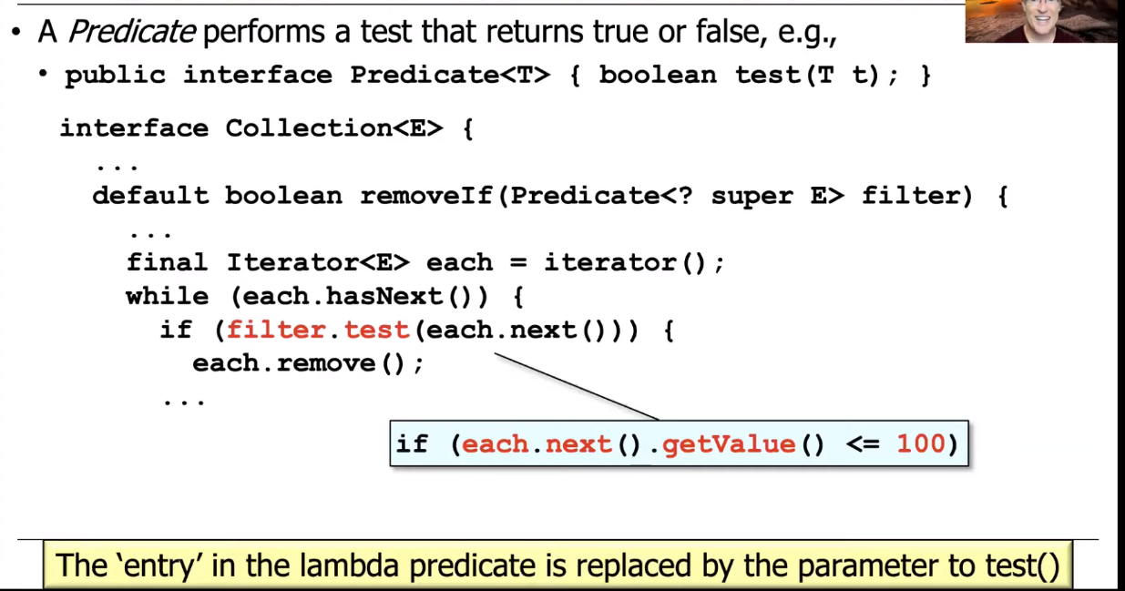

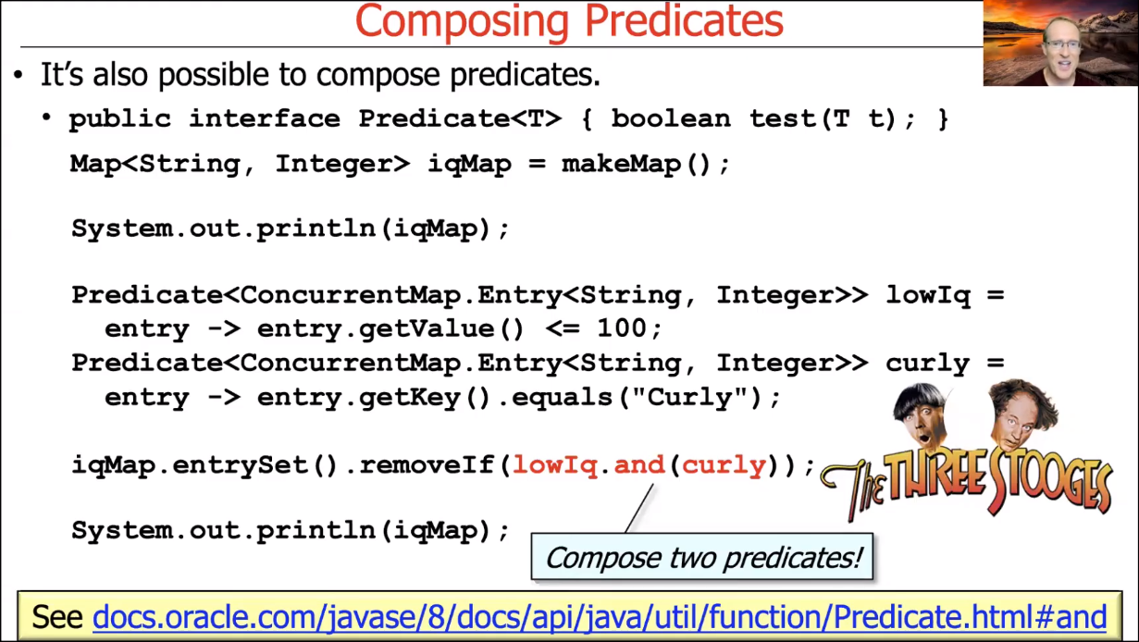

## **FUNCTION INTERFACE**

-------------------------------------------------------------------------------------------------------------------------------

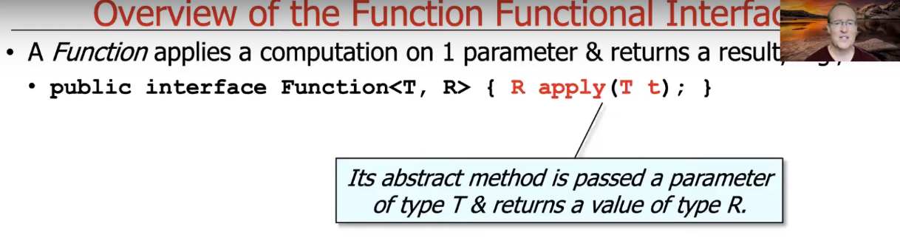

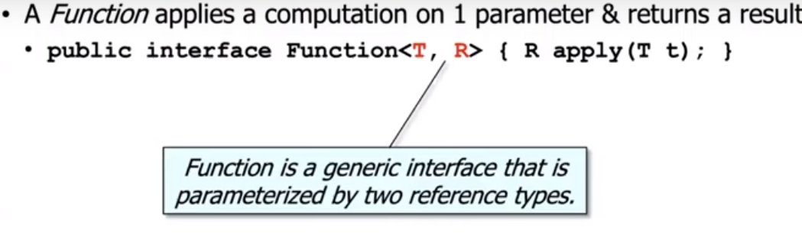

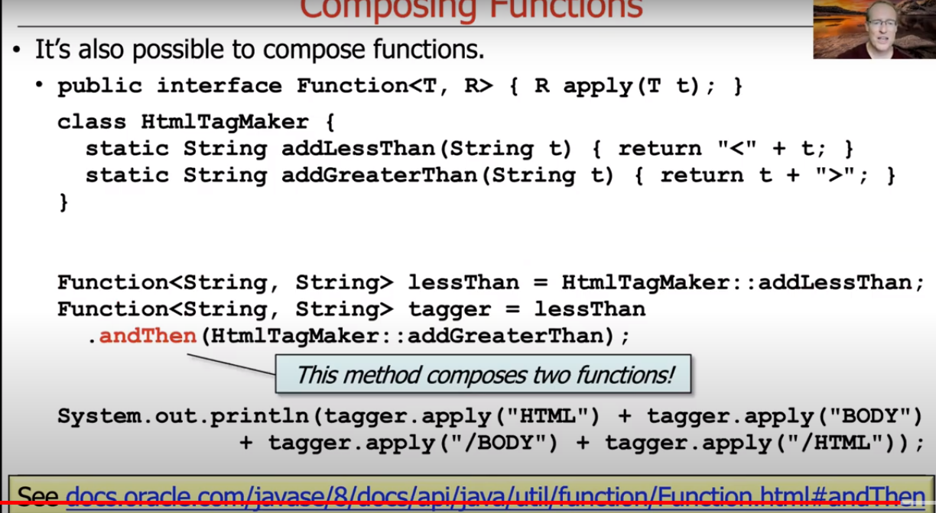

## **BI-FUNCTION INTERFACE**

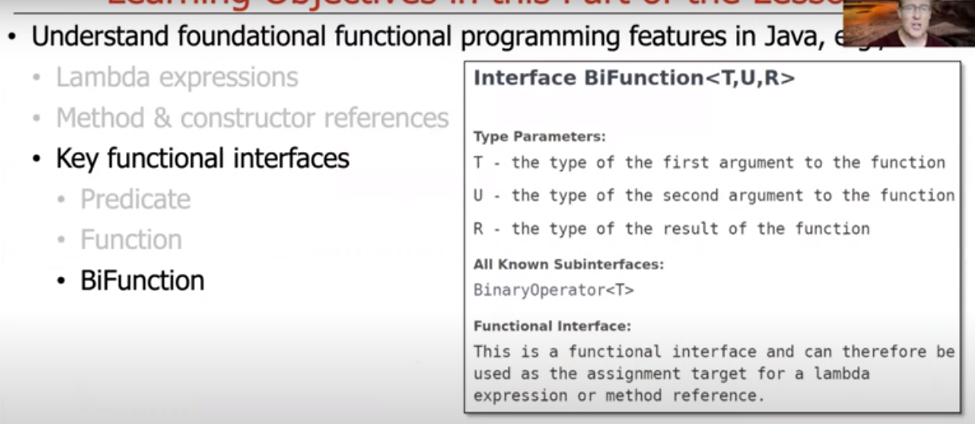

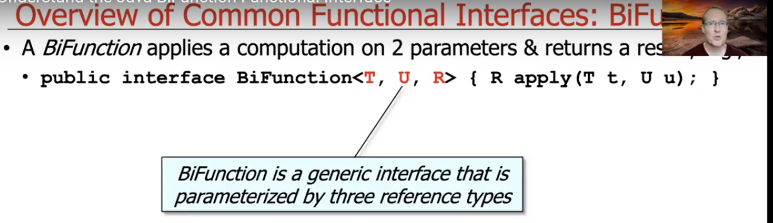

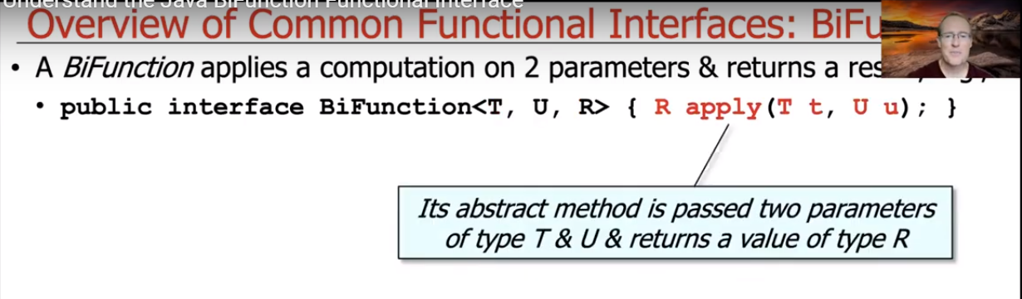

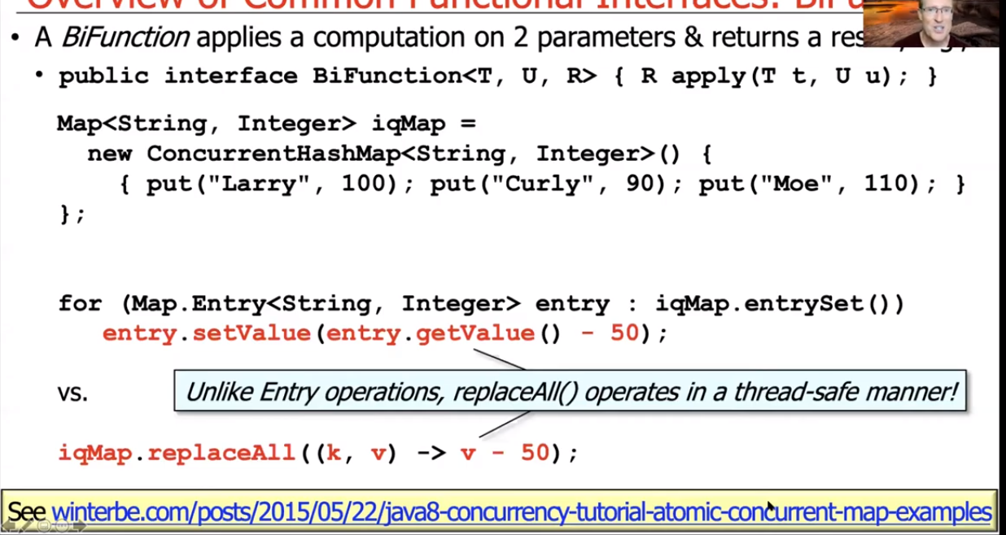

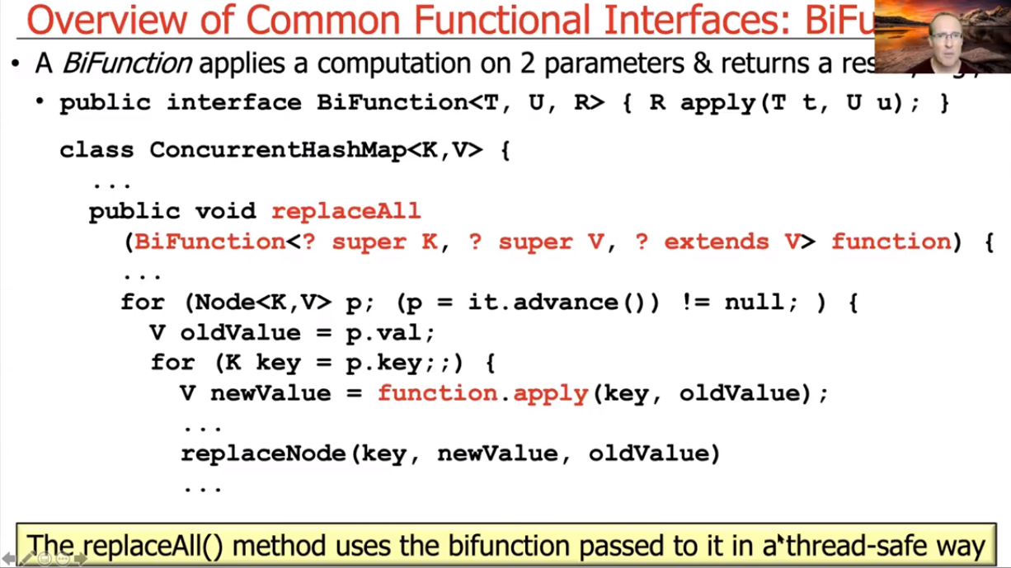

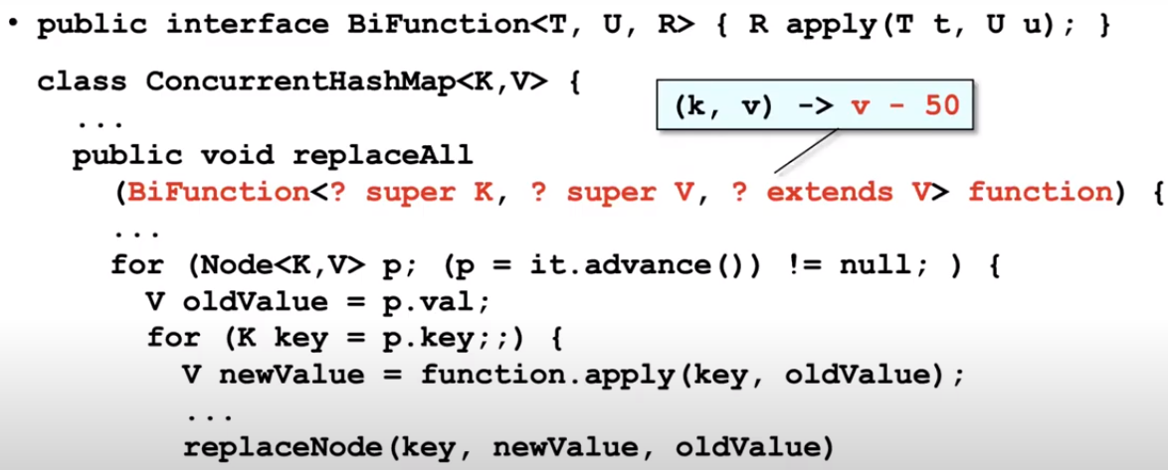

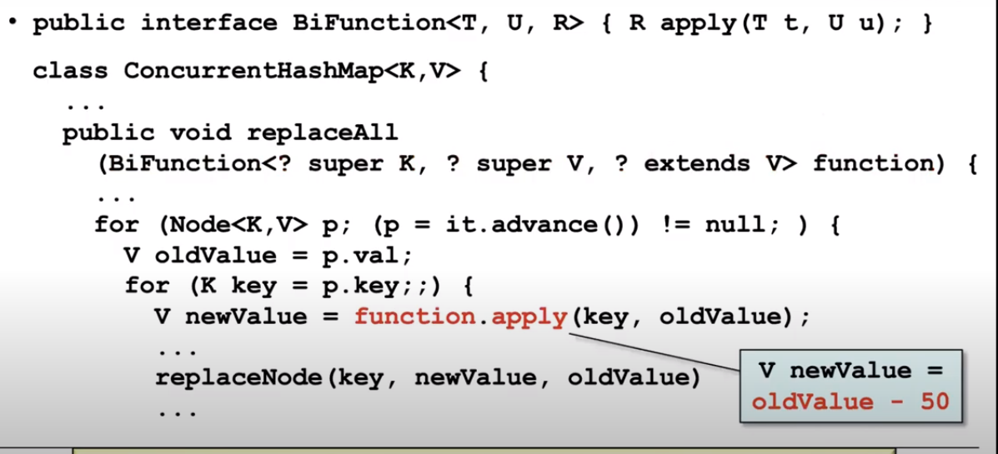

## **SUPPLIER INTERFACE**

-------------------------------------------------------------------------------------------------------------------------------

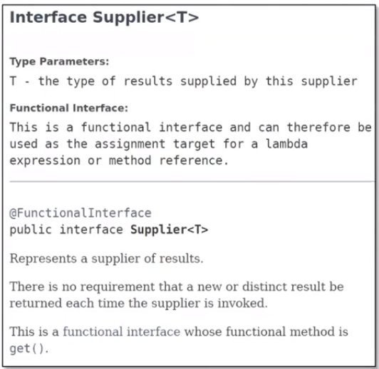

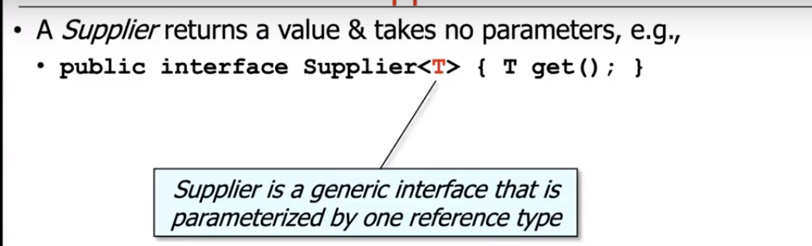

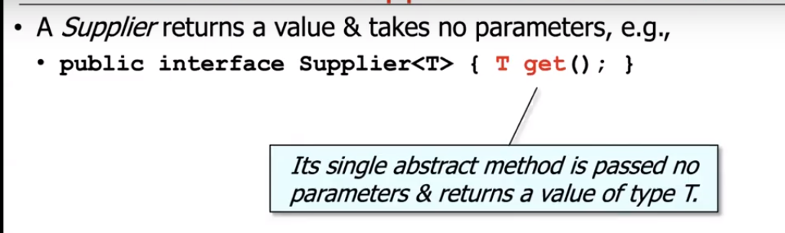

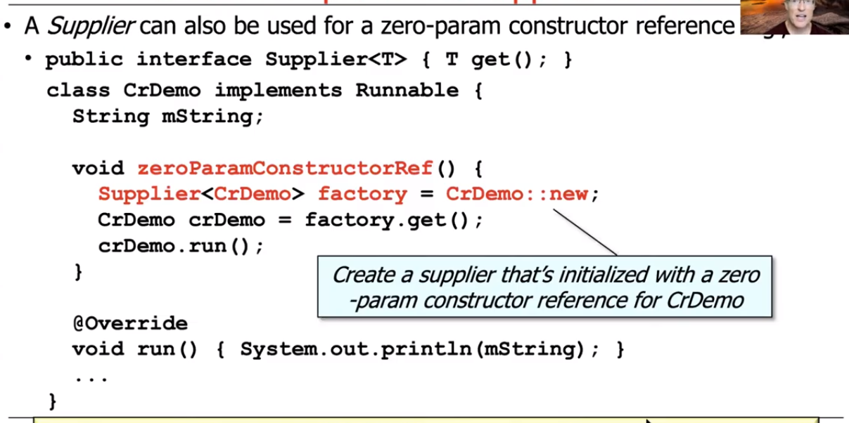

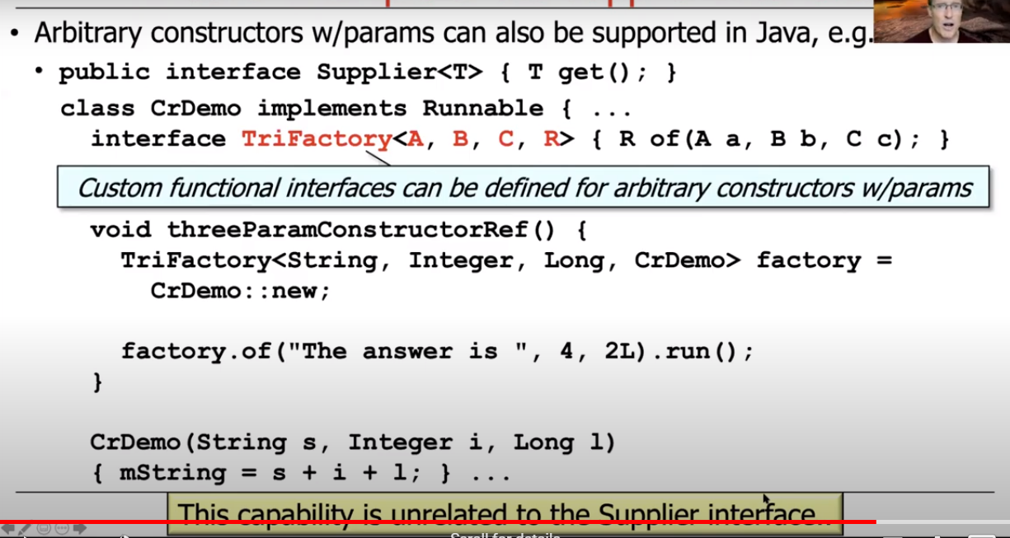

## **CONSUMER INTERFACES**

-------------------------------------------------------------------------------------------------------------------------------

